**MASK DETECTION**

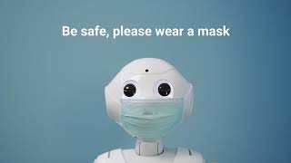

**DESCRIPTION:**

* This program detects the person whether he/she wearing a mask or not in real world with the video cam. Deep Neural Network concept used to achieve this, let’s about it in deep below.
* I got this idea of making a mask detection model because of covid outrage going on presently (2021).
* Nearly 3700+ images (With and Without Mask) were used to train the model and it took nearly 90 minutes to train in Google Collab since my laptop didn’t meet the requirements.
* In testing phase, the accuracy was almost over 90%.

**LIBRARY USED:**

1. **OpenCV**
2. **TensorFlow (Keras , MobileNet)**
3. **SkLearn**
4. **MatplotLib**
5. **OS**

**MODEL USED:**

1. **MobileNet**

**WHY MOBILENET?**

* MobileNet uses depthwise separable convolutions.It significantly reduces the number of parameters when compared to the network with regular convolutions with the same depth in the nets. This results in lightweight deep neural networks.

**MobileNet Model**

**What is MobileNet?**

As the name says, the MobileNet model is designed to be used in mobile applications, and it is TensorFlow’s first mobile computer vision model.

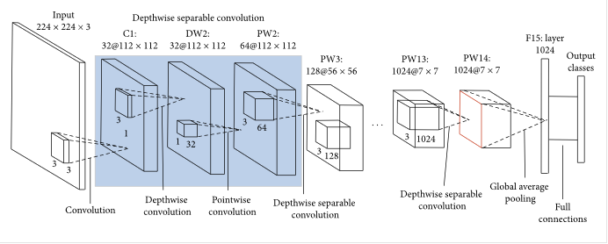

### Comparing MobileNets to Other Models:

To give a quick comparison in regards to size, the size of the full VGG16 network on disk is about 553 megabytes. The size of one of the currently largest MobileNets is about 17 megabytes, so that is a huge difference, especially when you think about deploying a model to a mobile app or running it in the browser.

A depthwise separable convolution is made from two operations.

1. **Depthwise convolution.**
2. **Pointwise convolution**.

MobileNet is a class of CNN that was open-sourced by Google, and therefore, this gives us an excellent starting point for training our classifiers that are insanely small and insanely fast.

**EPOCH :** It is set to 20.{Total Cycle}

**BATCH SIZE :** Is set to 32.{No of inputs per batch}

**LEARNING RATE :** Is set to 0.0001{For activation Function}.

**Training Phase Progress:**

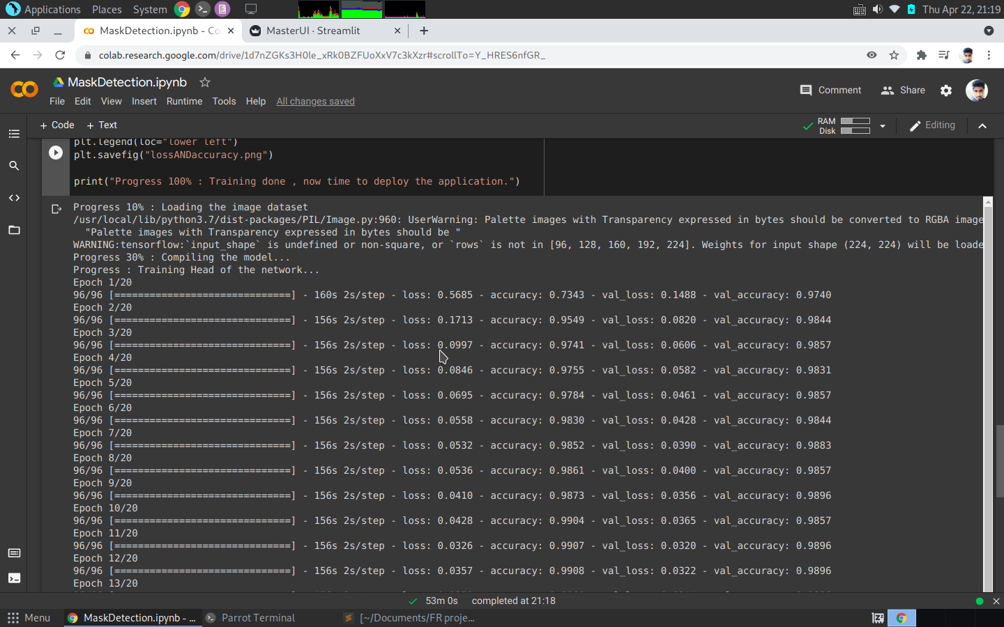

# C:\Users\rmnar\Documents\Training\training-2.png

# C:\Users\rmnar\Documents\Training\training-3.png

# Accuracy and Loss Graph

# While training

# C:\Users\rmnar\Documents\lossANDaccuracy.png

# ScreenShot of Real Time Application

# Conclusion:

MobileNets are a family of mobile-first computer vision models for TensorFlow, designed to effectively maximize accuracy while being mindful of the restricted resources for an on-device or embedded application.

MobileNets are small, low-latency, low-power models parameterized to meet the resource constraints of a variety of use cases. They can be built upon for classification, detection, embeddings, and segmentation.